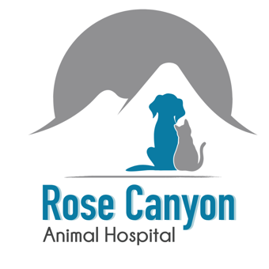
Rose Canyon Animal Hospital
New Client Form

Owner’s Name______________________________________________________________________________

Secondary Contact____________________________________ Relation___________________________

Address_________________________________ City__________________ State________ Zip______

Primary Phone Number______________________________________ (cell ___ house___)

Secondary Contact Phone Number___________________________ (cell___ house___)

Email Address_______________________________________________ Your D.O.B________________

How did you hear about us? Driving By Internet Search Yelp Other (please explain) _____________

Signature of Responsible Party______________________________________________________________

I understand that by signing this I am responsible for all charges incurred during the treatment of my pet(s). I am aware of this responsibility and understand all procedures / surgeries require a deposit (or full payment) at admittance and that payment is due when services are rendered. I also approve that if the staff happen to get an adorable picture of my pet it can be used on social media or on the hospital website.

Please Complete all Pet information Below

 | Pet #1 | Pet #2 | Pet #3
Name
D.O.B
BREED
COLOR
GENDER
SPAYED/NEUTERED?
ANY CURRENT ILLNESS/MEDICATION?
ANY ALLERGIES?
PET INSURANCE? WHICH ONE?

